

**Customer Activation and Retention**

Submitted by:

Rajesh.J

**ACKNOWLEDGMENT**

Resources that helped me and guided me in completion of the project is as follows:

DataTrained Documents & Trainings

**INTRODUCTION**

* Business Problem Framing

Customer satisfaction has emerged as one of the most important factors that guarantee the success of online store; it has been posited as a key stimulant of purchase, repurchase intentions and customer loyalty. A comprehensive review of the literature, theories and models have been carried out to propose the models for customer activation and customer retention

* Conceptual Background of the Domain Problem

Five major factors that contributed to the success of an e-commerce store have been identified as: service quality, system quality, information quality, trust and net benefit. The research furthermore investigated the factors that influence the online customers repeat purchase intention. The combination of both utilitarian value and hedonistic values are needed to affect the repeat purchase intention (loyalty) positively. The data is collected from the Indian online shoppers. Results indicate the e-retail success factors, which are very much critical for customer satisfaction.

* Review of Literature

This is a comprehensive summary of the research done on the topic. This project explains about customer activation and customer retention.

This project explains about the factors affecting the Customers retention.

* Motivation for the Problem Undertaken

To analyze and have more knowledge of the respective domain and hence forth predicting the Customers retentions was motivational and made learning of some concepts like EDA and data processing.

**Analytical Problem Framing**

* Mathematical/ Analytical Modeling of the Problem

Some of the basic mathematical calculations were used for data processing such as for null values checking and uniqueness checking.

Statistical methods of plotting were handled between variables.

* Data Sources and their formats

|  |  |
| --- | --- |
| Data source is provided with excel file and with the data’s giving  information’s about the factors responsible for customers retention.  And a document describing about the Project in details. |  |
|  |
|  |

* Data Pre-processing Done

Checking for the rows and columns.

Checking for the null values and duplicates.

Checking for the uniqueness in data’s.

* Data Inputs- Logic- Output Relationships

Data inputs are the factors which help in identifying the identification of the Customer retention concept.

Exploratory data analysis has been done to find the customers interest in online shopping.

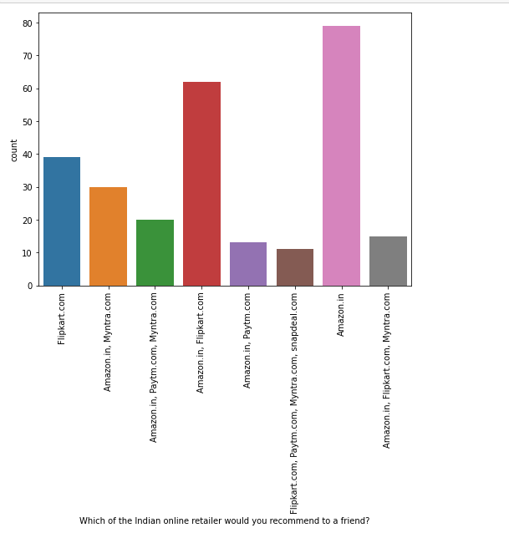

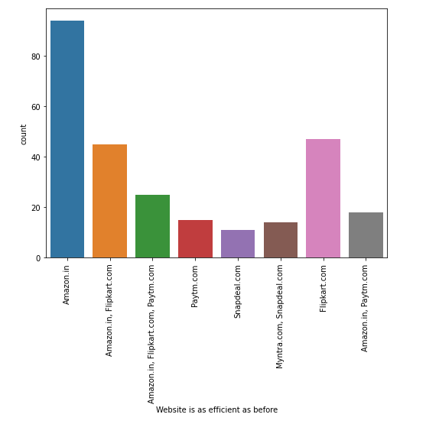

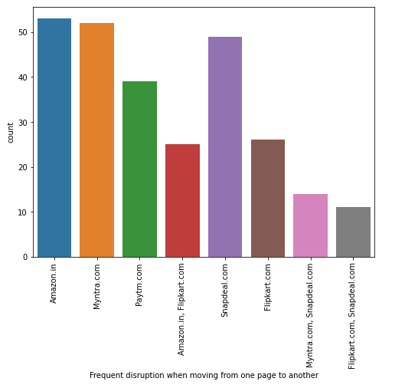 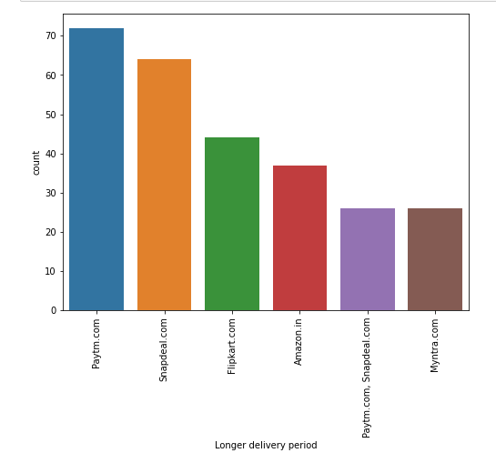 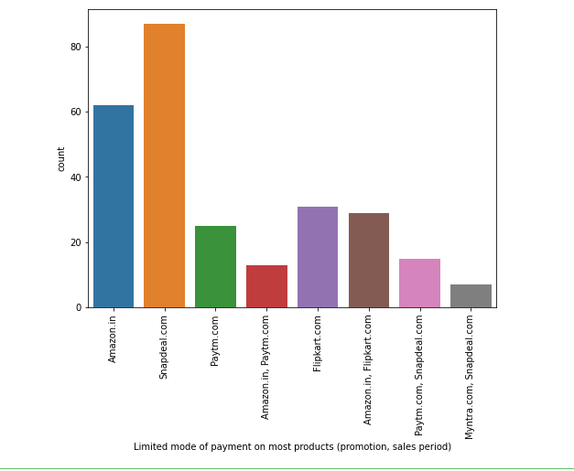 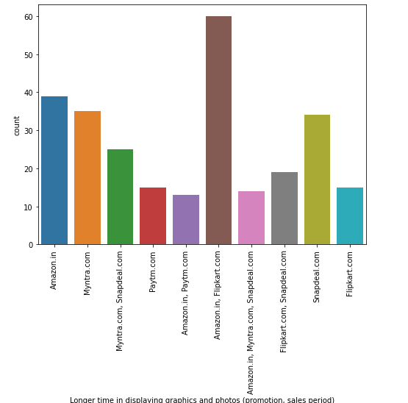 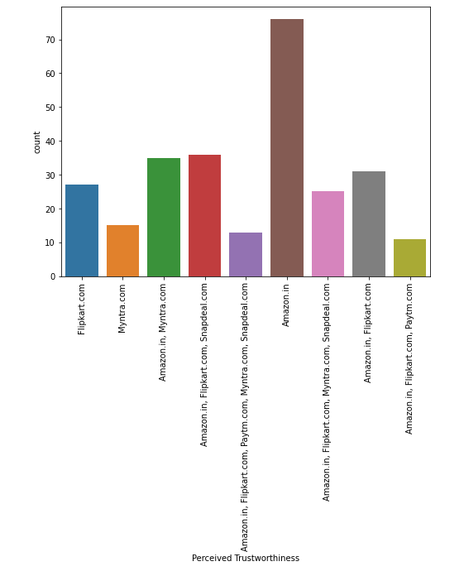 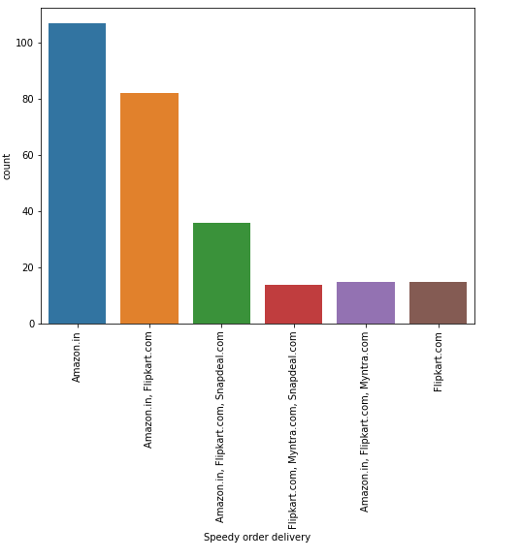 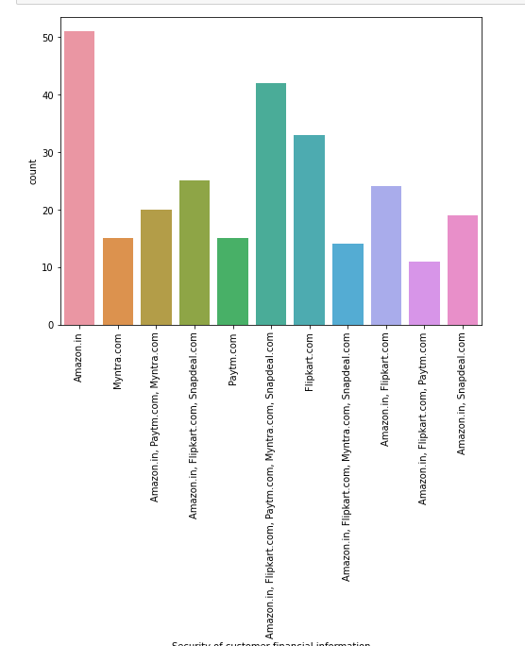 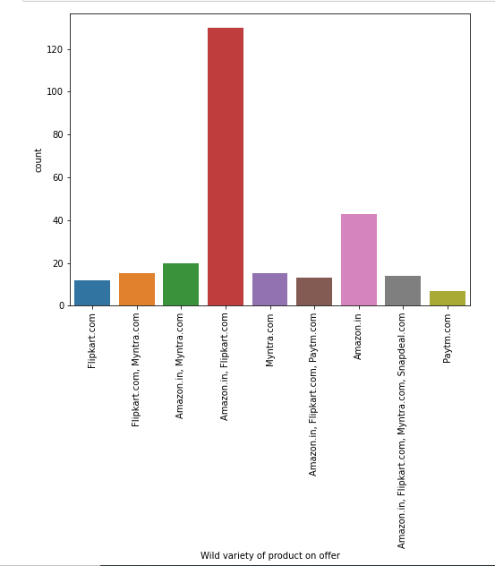

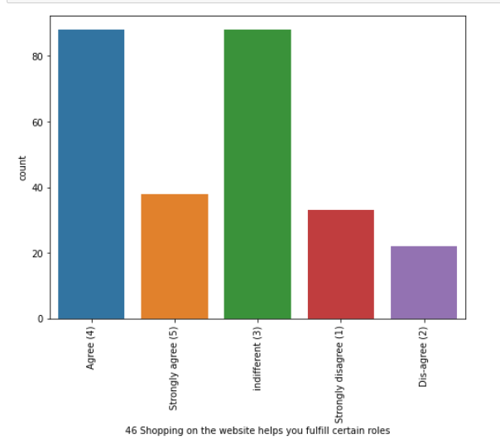 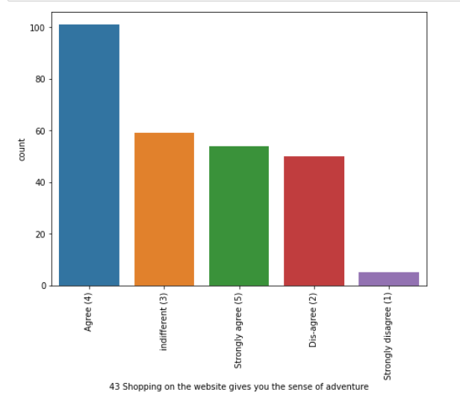 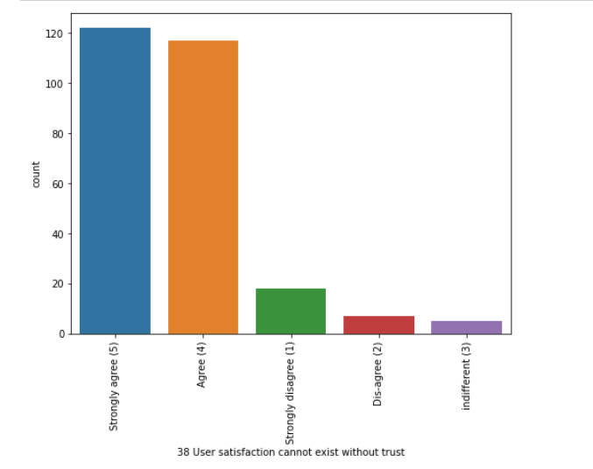 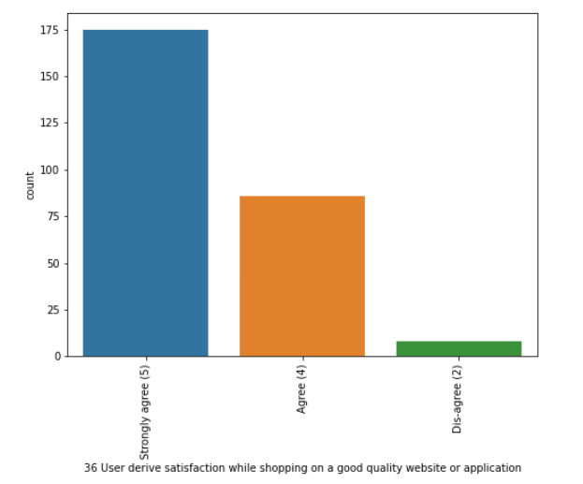 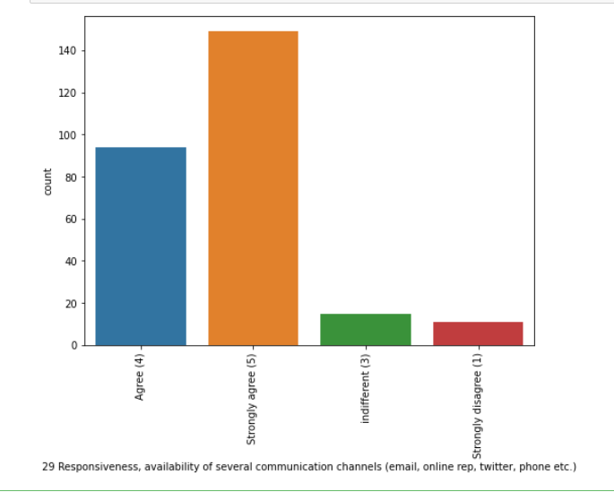

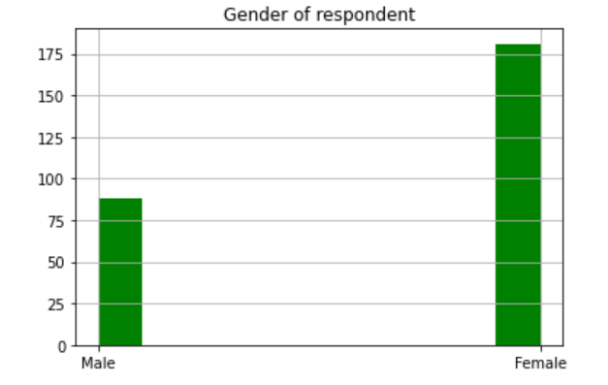 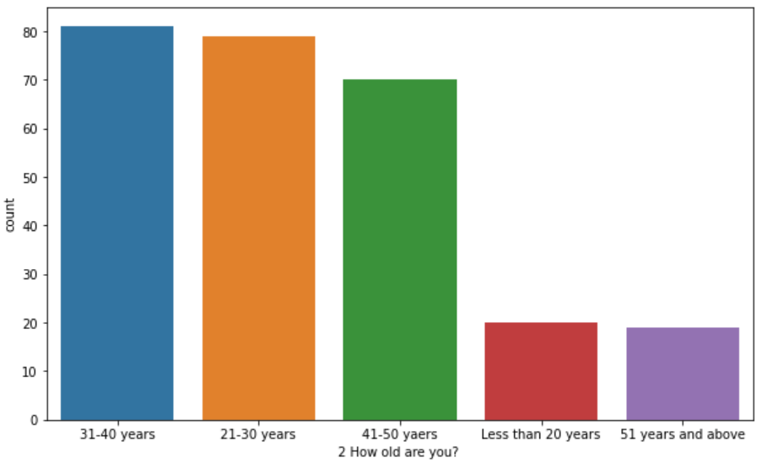

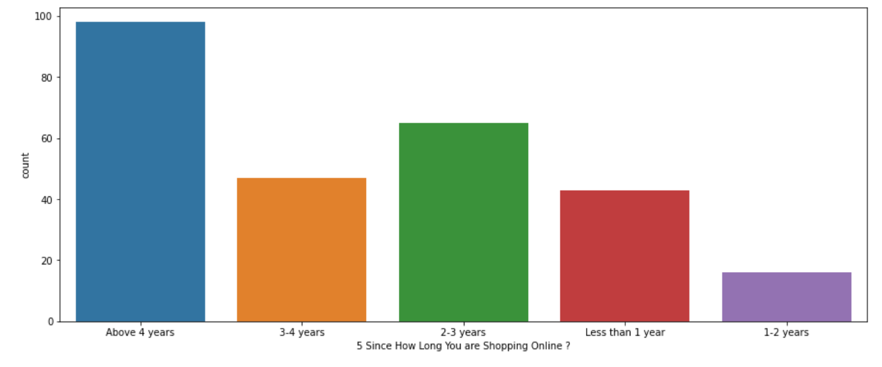 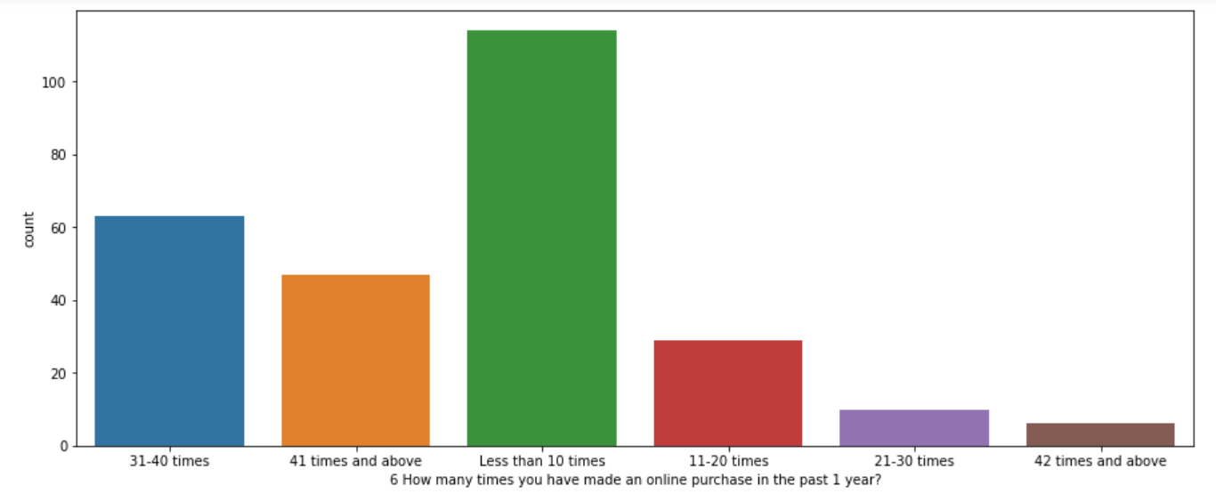 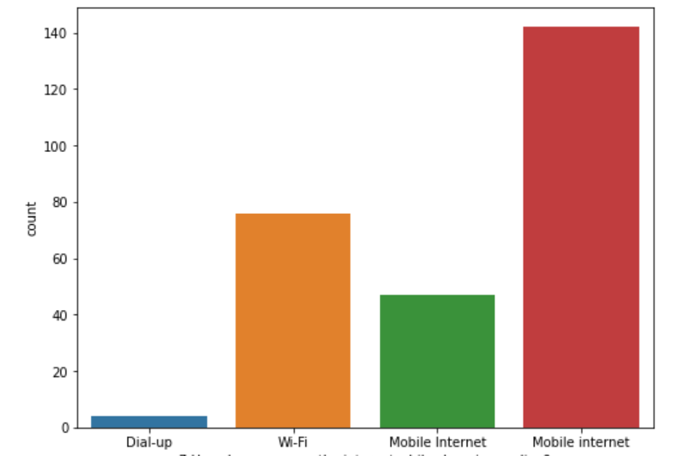

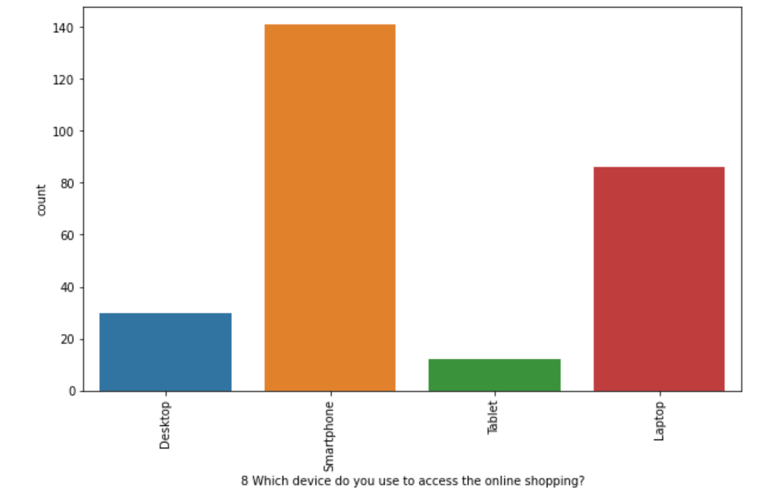 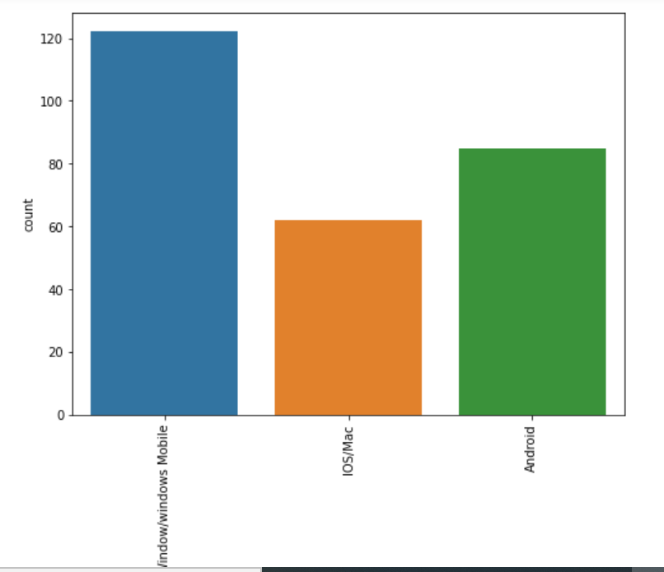 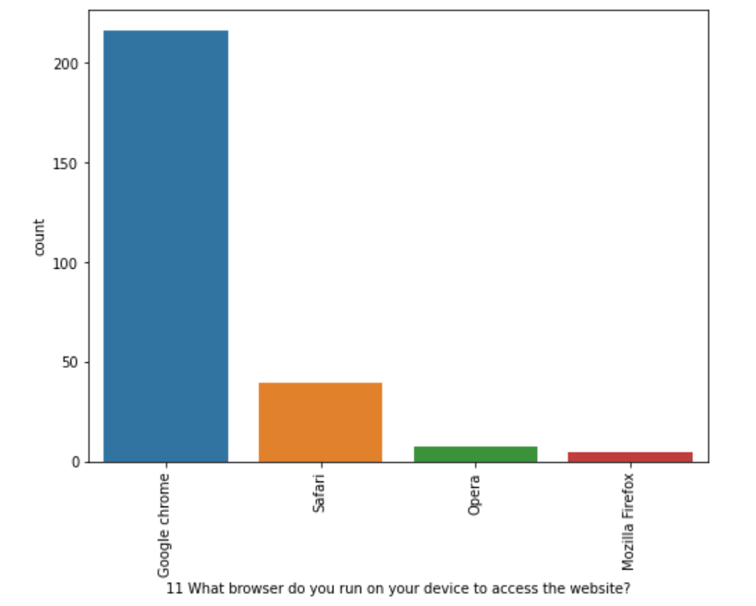 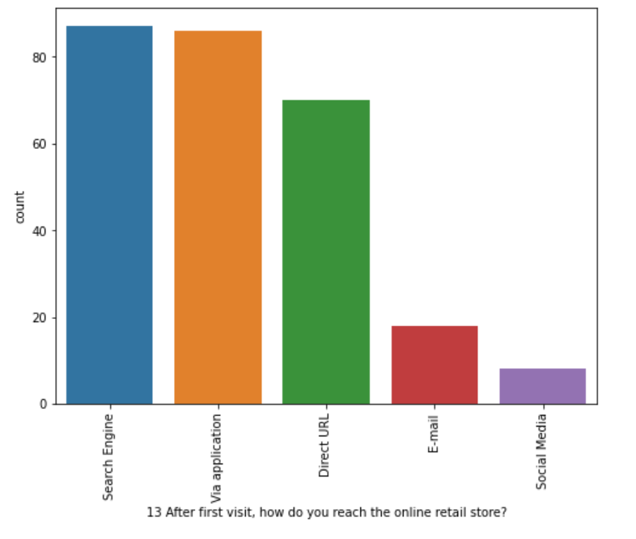

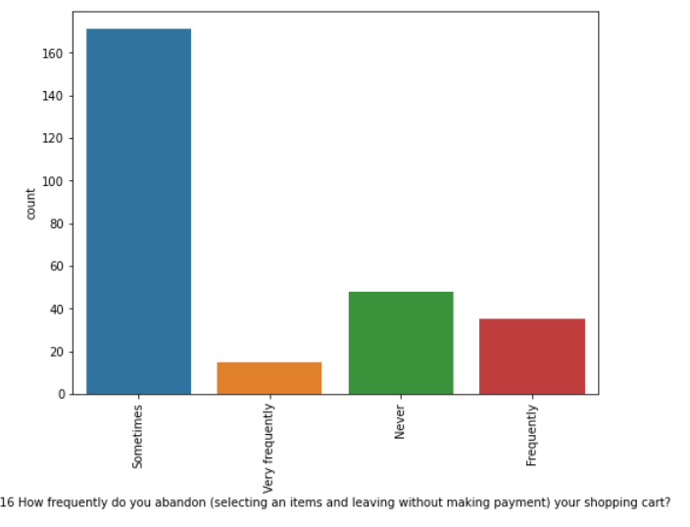 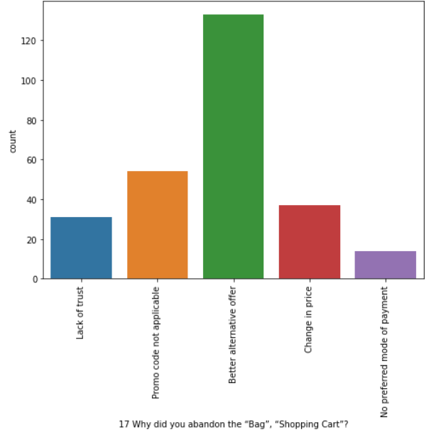 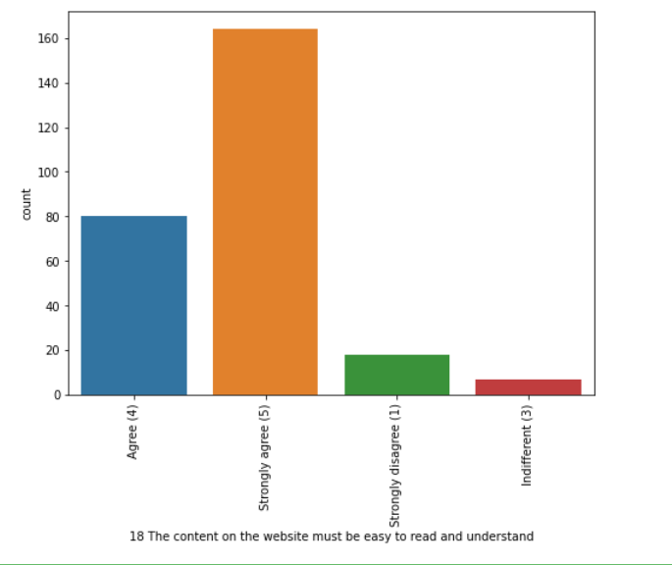

* Hardware and Software Requirements and Tools Used

System with 4GB ram,

Jupyter notebook for coding,

Excel,

Word document,

Anacondas full set installations

With libraries like:

Pandas

numpy

matplotlib

seaborn

sklearn

* Interpretation of the Results

We are getting much information about the online stores and their ratings for having customer retention.

Probability of people’s choice is with Amazon.in as there is lot of customer satisfaction and on the basis of security and service quality, system quality, information quality, trust and net benefit .

**CONCLUSION**

* Key Findings and Conclusions of the Study

Results indicate the e-retail success factors, which are very much critical for customer satisfaction. The combination of both utilitarian value and hedonistic values are needed to affect the repeat purchase intention (loyalty) positively. Customer satisfaction has emerged as one of the most important factors that guarantee the success of online store; it has been posited as a key stimulant of purchase, repurchase intentions and customer loyalty

Majority of the people strongly agree that Online store plays vital role in Purchases with many factors as explained above exploratory analysis. Customer satisfaction has emerged as one of the most important factors that guarantee the success of online store. Major factors that contributed to the success of an e-commerce store have been identified as: service quality, system quality, information quality, trust and net benefit. The research furthermore investigated the factors that influence the online customers repeat purchase intention. The combination of both utilitarian value and hedonistic values are needed to affect the repeat purchase intention (loyalty) positively. The data is collected from the Indian online shoppers. Results indicate the e-retail success factors, which are very much critical for customer satisfaction.

As per the given data set, almost most of the factors that help in customer retention shows the higher preference with Amazon.in, it has the highest recommendation to other friends.